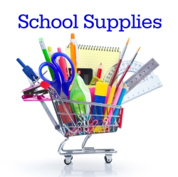 **Winterset Elementary**

**2023-2024 Supply List**

**Third Grade**

1 handheld pencil sharpener

3 pink erasers

3 -24 pack Crayola crayons

1 box Crayola Markers

1 package colored pencils

1 pair scissors

1 Bottle 8oz Elmer’s Glue All

3 glue sticks

3 plastic folders in red, blue, & yellow

1 pencil box (8”x 5”x 2”)

1 pair of headphones

4 boxes of Kleenex

1 container Clorox wipes

36 Ticonderoga Pencils

Boys – Gallon Size Ziploc Bags

Girls – Quart Size Ziploc Bags

1 Basic Watercoler Basic Paint Set